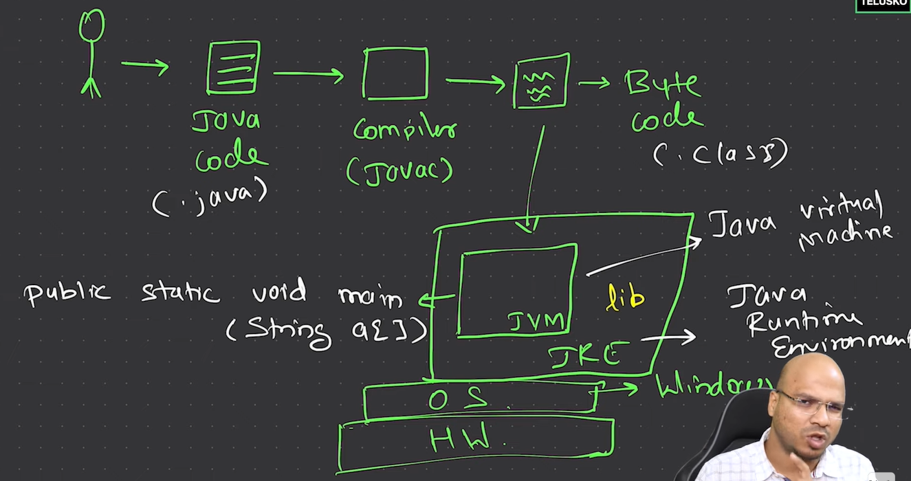

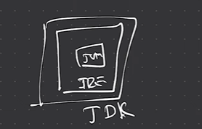

**>>** JVM does not look for just main method, it looks for entire method signature “public static void main(String a[])”

**>>** Java is called WORA -> Write Once Run Anywhere

**>>** **JIT**: Just In Time Compiler: The Just-In-Time (JIT) compiler is a component of the runtime environment that improves the performance of Java™ applications by compiling bytecodes to native machine code at run time

**>> AOT**: Ahead Of Time Compiler: It used to compile byte code to native code prior to the execution by the JVM.

**>> Java Features:**

Simple, Secure, Portable, Object-Oriented, Robust, Multithreaded, Architechture-neutral, Interpreted, High performance, Distributed, Dynamic.

**Secure:** In java, we don’t have pointers, so we cannot access out-of-bound arrays i.e it shows **ArrayIndexOutOfBound Exception** if we try to do so. That’s why several security flaws like stack corruption or buffer overflow are impossible to exploit in Java. Also, java programs run in an environment that is independent of the os environment which makes java programs more secure.

**Robust**: The main features of java that make it robust are garbage collection, Exception Handling, and memory allocation.

>> beginning with JDK 8 it is now possible to define a default implementation for a method specified by an interface. I f no implementation for a default method is created the the default defined by the interface is used.

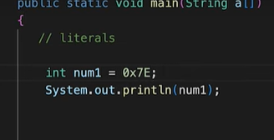

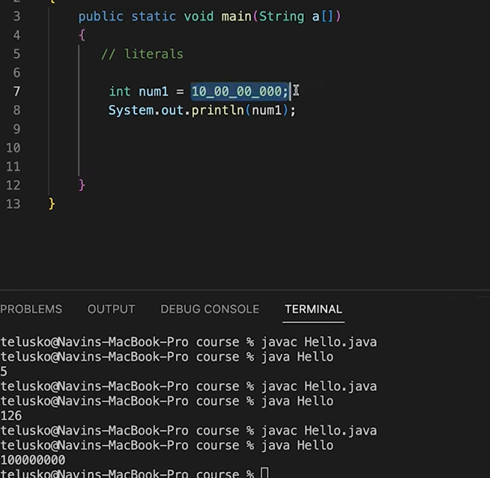

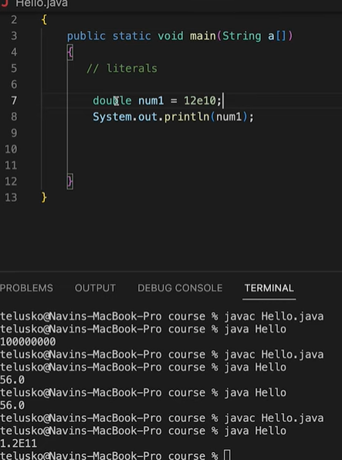

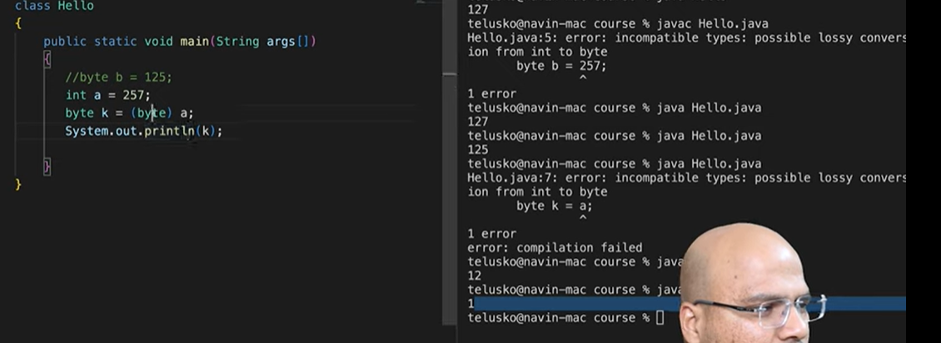

Here 257 is out of range so printing 257%256

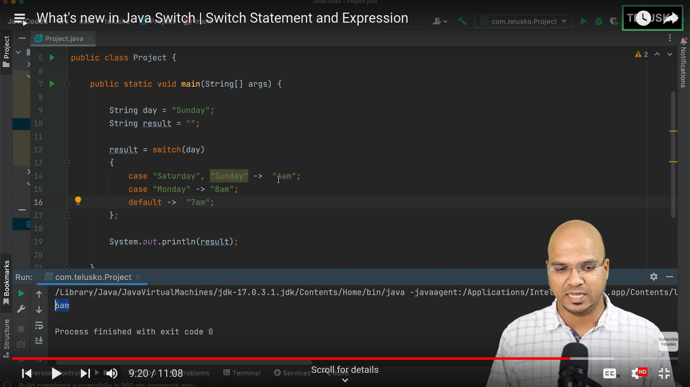

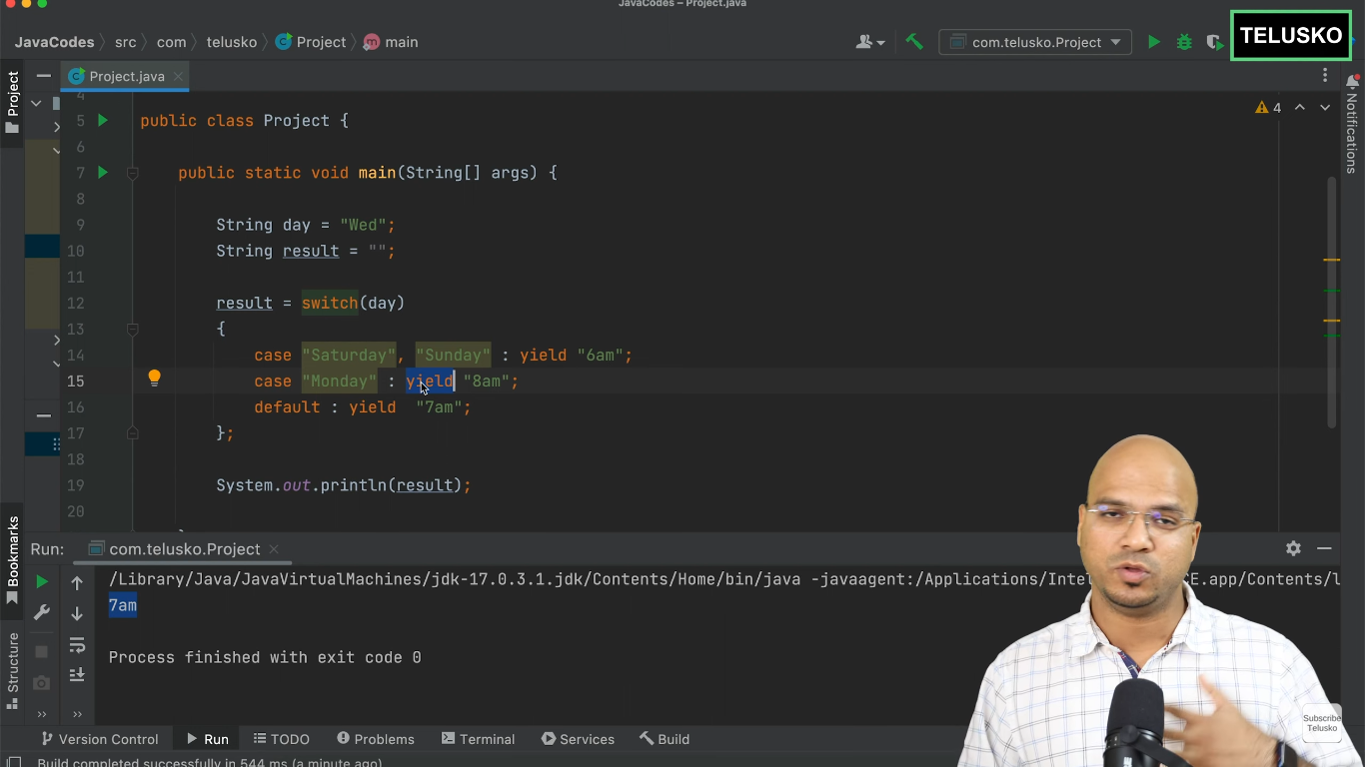

**>>**

**Car c = new Car(); Memory management in sequencial order**

1. **Class Loading**:

- **Check if Class is Loaded**: The JVM checks if the `Car` class is already loaded. If not, the class loader loads it into memory.

- **Class Verification**: The JVM verifies the bytecode of the `Car` class for correctness and security.

- **Class Preparation**: The JVM allocates memory for static variables of the `Car` class and initializes them to default values.

- **Class Resolution**: The JVM resolves symbolic references in the `Car` class to actual references.

2. **Reference Variable Creation**:

- **Reference Variable Creation**: A reference variable `c` of type `Car` is declared. If `c` is a local variable, it is created on the stack. If it is an instance variable, it is part of the memory layout of the containing object, which resides on the heap.

3. **Object Creation**:

- **Memory Allocation**: The JVM allocates memory for a new `Car` object on the heap. The size of the allocated memory depends on the fields defined in the `Car` class.

- **Default Initialization**: The memory allocated for the `Car` object is initialized to default values (e.g., `0` for numeric types, `null` for reference types, `false` for boolean).

- **Constructor Call**: The constructor of the `Car` class is called, which may further initialize the fields of the `Car` object with specific values.

4. **Reference Assignment**:

- **Assign Memory Address**: The memory address of the newly created `Car` object is assigned to the reference variable `c`.

5. **Garbage Collection**:

- **Reachability Check**: The `Car` object remains in memory as long as it is reachable through the reference variable `c` or any other references.

- **Object Eligibility**: When the reference variable `c` goes out of scope or is assigned to another object or `null`, the `Car` object becomes eligible for garbage collection.

- **Garbage Collection Process**: The garbage collector eventually reclaims the memory used by the `Car` object, making it available for future allocations.

So the correct order is:

1. Class loading (if needed)

2. Reference variable creation (`c` on the stack)

3. Object creation (memory allocation on the heap)

4. Reference assignment (heap address assigned to `c`)

5. Garbage collection (if applicable)

This revised sequence correctly reflects how the JVM manages memory when the statement `Car c = new Car();` is executed.

--------------------------

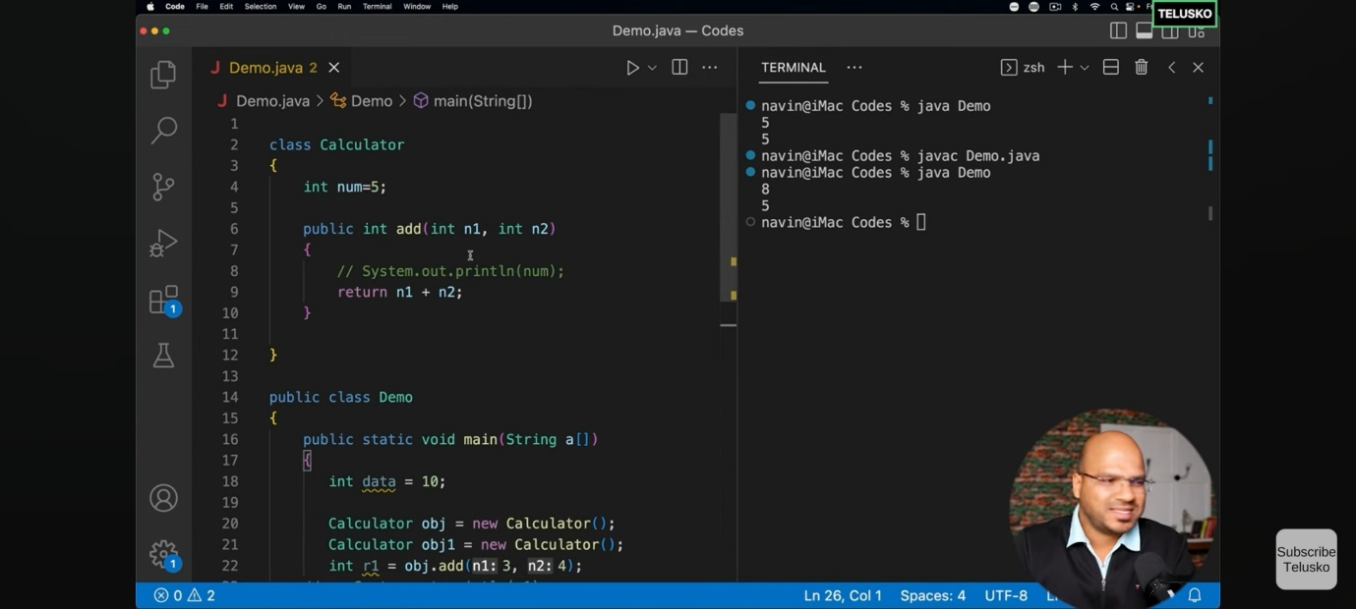

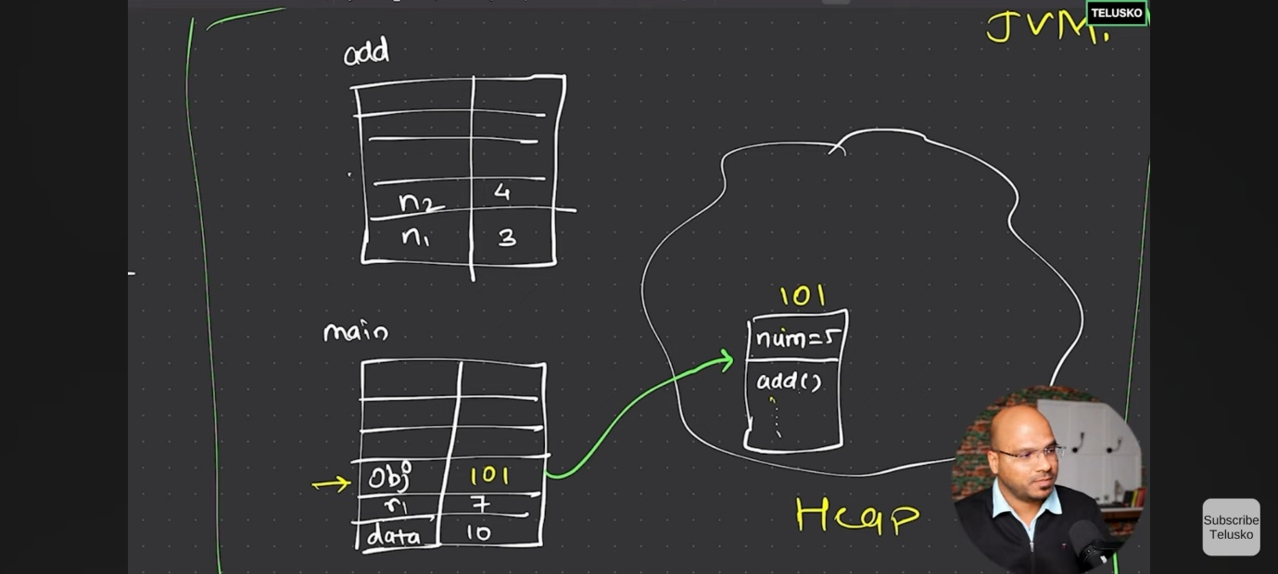

**>>How Main method works:** In Java, the main class (the class containing the `main` method) serves as the entry point for the application. When you run a Java application, the Java Virtual Machine (JVM) starts executing the `main` method without explicitly creating an instance of the main class. Here’s how memory management works in this context:

1. **Static Context**: The `main` method is `static`, meaning it belongs to the class itself rather than an instance of the class. Static methods and variables are stored in a special area of memory known as the **method area** (part of the heap in many JVM implementations).
2. **Method Area**: The method area stores class-level data, including static variables, method definitions (including the `main` method), and other class-level structures. When the JVM loads the main class, it allocates memory for these static members in the method area.
3. **Stack Memory**: When the JVM starts executing the `main` method, it creates a stack frame for it in the **stack memory**. The stack is used for method execution, including local variables and method call management. Each thread has its own stack.
4. **Heap Memory**: If the `main` method or any other part of the program creates objects using the `new` keyword, these objects are allocated memory in the **heap**. The heap is shared among all threads and is managed by the JVM’s garbage collector, which reclaims memory from objects that are no longer reachable.

To summarize, the `main` method and any other static members of the main class reside in the method area, while objects created during the execution of the program are stored in the heap. Local variables within the `main` method (or any other method) are stored in the stack. This division of memory areas helps in efficient memory management and execution of Java programs.

**>>**

**Instances Variables vs Other Variables:**

Instance variables in Java differ from other types of variables in several key ways:

1. **Scope and Lifetime**:

- **Instance Variables**: These are defined within a class but outside any method, constructor, or block. They are created when an object of the class is instantiated and destroyed when the object is destroyed. Each object has its own copy of instance variables.

- **Local Variables**: These are defined within a method, constructor, or block. They are created when the method, constructor, or block is entered and destroyed once it exits. They are not accessible outside their defining method, constructor, or block.

- **Static Variables**: Also known as class variables, these are defined within a class using the `static` keyword but outside any method, constructor, or block. There is only one copy of a static variable, regardless of how many objects of the class are created. They are associated with the class itself rather than any specific instance.

2. **Memory Location**:

- **Instance Variables**: Stored in the heap, as part of the object.

- **Local Variables**: Stored in the stack, as part of the stack frame for the method, constructor, or block in which they are defined.

- **Static Variables**: Stored in the method area (part of the heap in many JVM implementations), shared among all instances of the class.

3. **Default Values**:

- **Instance Variables**: Automatically initialized to default values (e.g., `0` for integers, `null` for object references) if not explicitly initialized.

- **Local Variables**: Must be explicitly initialized before use; they do not get default values.

- **Static Variables**: Automatically initialized to default values if not explicitly initialized.

4. **Access Modifiers**:

- **Instance Variables**: Can be marked with access modifiers (`private`, `protected`, `public`) to control their visibility.

- **Local Variables**: Cannot have access modifiers; their scope is limited to the method, constructor, or block in which they are declared.

- **Static Variables**: Can also be marked with access modifiers and are accessed using the class name.

5. **Use Case**:

- **Instance Variables**: Hold the state of an object. Different objects can have different values for their instance variables.

- **Local Variables**: Used for temporary storage of data within a method, constructor, or block.

- **Static Variables**: Used for values shared among all instances of a class, such as constants or counters. Here is a quick example to illustrate the differences:

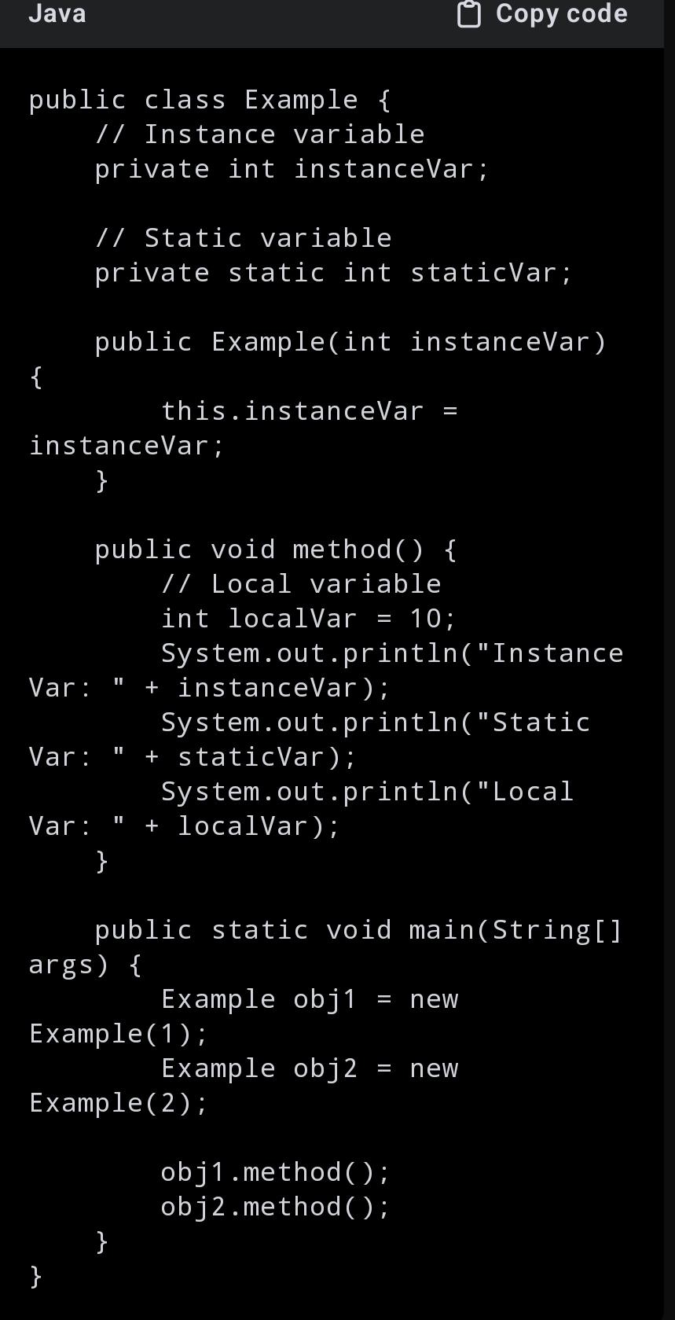

In this example:

- `instanceVar` is an instance variable, so each `Example` object has its own copy.

- `staticVar` is a static variable, shared among all `Example` objects.

- `localVar` is a local variable, accessible only within the `method`.

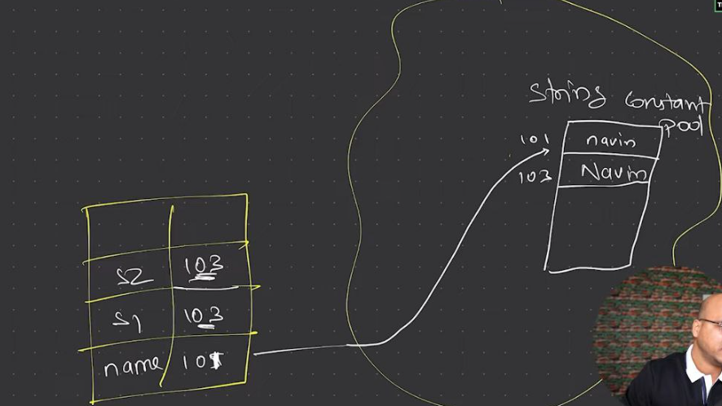

**>>**Class.forName("<classname>") is to load the class

**>>**The static keyword in Java is used to define class-level variables and methods, meaning they belong to the class itself rather than any specific instance of the class. This has multiple uses and benefits. First, static variables are shared among all instances of a class, ensuring there is only one copy of the variable, which helps in saving memory and maintaining consistency across all instances. For example, a static counter variable can track the number of objects created, accessible and modifiable by all instances. Second, static methods can be called directly using the class name without needing to create an object. This is particularly useful for utility or helper methods that perform tasks not dependent on instance-specific data, such as mathematical calculations or configuration settings. Additionally, static blocks allow for static initialization, which runs once when the class is loaded, enabling the setup of static variables. Overall, the static keyword enhances memory efficiency, simplifies access to common methods and variables, and ensures consistent state management across all instances of a class.

**>>**The heap is divided into generations (Young Generation, Old Generation) to optimize garbage collection.The Young Generation is collected frequently because it contains many short-lived objects.The Old Generation is collected less frequently but can still undergo garbage collection when it fills up.

**>>**The method area in the Java Virtual Machine (JVM) is a part of the JVM's memory where class-level structures are stored. It serves several key purposes in managing Java programs:  
  
1. Class Metadata:   
   - When a class is loaded by the JVM, its metadata (information about the class such as its name, modifiers, superclass, interfaces, etc.) is stored in the method area.  
     
2. Static Fields:   
   - Static variables declared within a class are stored in the method area. These variables are shared among all instances of the class.  
  
3. Method Data:   
   - The method area contains information about methods and constructors of classes, including bytecode (compiled code of methods).  
  
4. Constant Pool:   
   - Each class loaded by the JVM has a runtime constant pool, which is part of the method area. This pool contains constants, literals, and symbolic references used within the class.  
  
5. Memory Management:   
   - The method area is managed by the JVM's memory manager, and while it supports garbage collection, it typically collects less frequently compared to the heap.  
  
6. Shared among Threads:   
   - The method area is shared among all threads running within the JVM. This shared access ensures consistency in class data and method execution across the application.  
  
Overall, the method area plays a crucial role in storing and managing class-related information and static variables, supporting the execution and management of Java programs within the JVM.

**>>this** keyword is a reference to the current instance of the class in which it is used. this reference is not created in memory in the same way that objects and variables are. Instead, it is a logical construct provided by the Java compiler that exists as part of the method or constructor's context. When an object is created using the new keyword, the object itself is allocated in the heap memory. The **this** reference is implicitly passed to instance methods and constructors as a hidden parameter.

**>>**If you call a method from a constructor that is overridden in a subclass, the method from the subclass will be called.

**Reason**:

Dynamic Method Dispatch:

In Java, non-static methods are by default virtual, meaning the method that gets executed is determined at runtime based on the actual object's type, not the reference type. This is called dynamic method dispatch or late binding.When an object is being created, the constructor of the class and its parent classes are executed in a specific order. If a method call occurs in a constructor, the virtual method mechanism looks up the method in the runtime type of the object being created, not the type where the constructor is defined.

Object Creation Process:

When a subclass object is created, Java first initializes the superclass part of the object by calling the superclass constructor. If the superclass constructor calls an overridden method, Java calls the overridden method in the subclass

**>>**In Java, when you create an object of a subclass, the constructor of the superclass is automatically called. This happens because of the way object initialization works in Java, ensuring that the entire object is fully initialized, including the parts inherited from any superclasses. Here’s a detailed explanation:

Implicit Constructor Call:

When you instantiate a subclass, Java implicitly calls the constructor of its superclass before executing the subclass constructor.This ensures that the inherited fields and methods from the superclass are properly initialized before the subclass's own initialization code runs.

Constructor Chaining:

Constructor chaining refers to the process where a constructor calls another constructor, either in the same class or in the superclass. In Java, if a constructor does not explicitly call another constructor using this() (for the same class) or super() (for the superclass), the compiler automatically inserts a call to the no-argument constructor of the superclass as the first line of the constructor.

**>>**

Advantages of Using List Reference while creating a ArrayList object:

Flexibility:

If you use a List reference, you can easily change the implementation to another List type (e.g., LinkedList) without changing the code that uses the List.List<String> list = new LinkedList<>();

Abstraction:

Using interfaces promotes abstraction, making your code more modular and easier to maintain. You can work with higher-level concepts (like a list) rather than specific implementations.

Code Reusability:Code that uses the List interface can work with any implementation of List, increasing code reusability and reducing coupling.

Easier Testing:Using interfaces makes it easier to substitute different implementations during testing, which can be useful for unit tests.

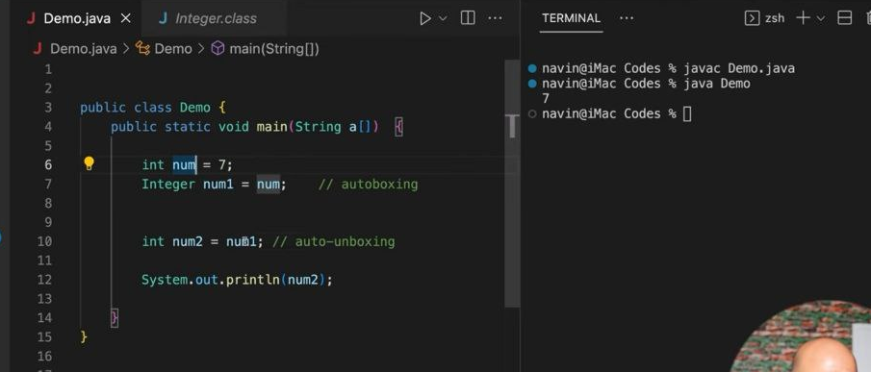

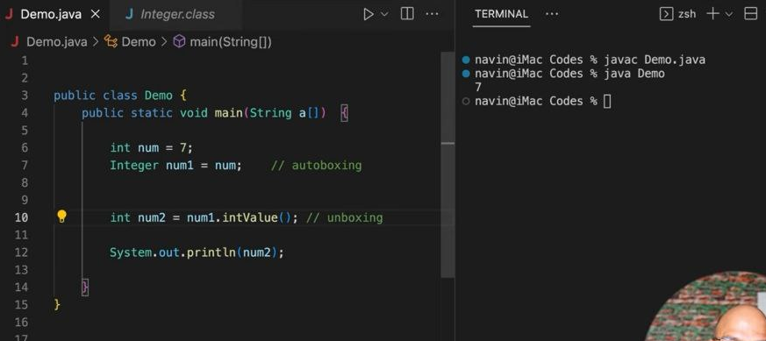

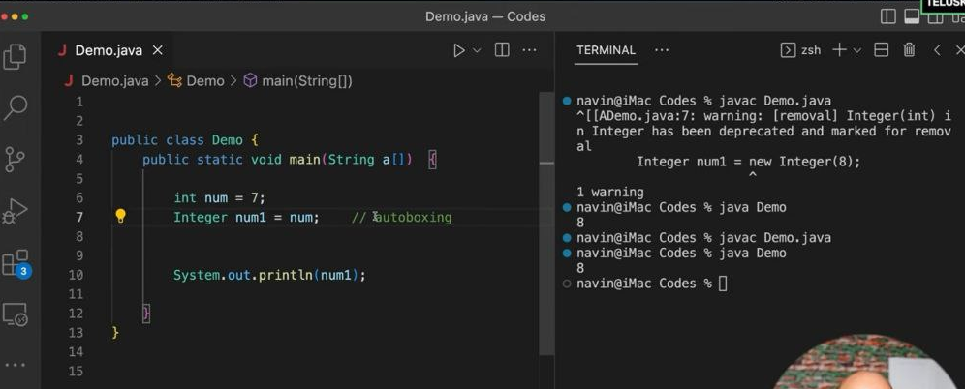

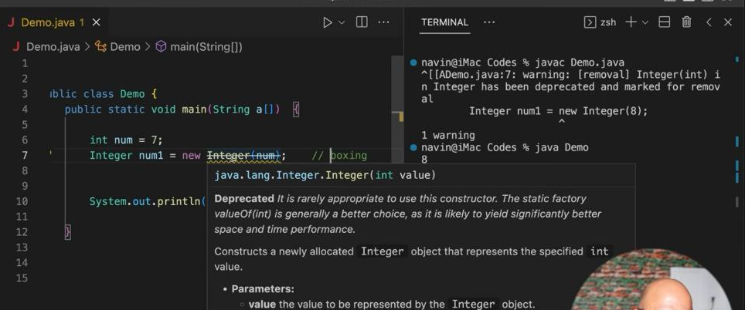

### Boxing

Boxing is the process of converting a primitive type into its corresponding wrapper class object. This is done manually before Java 5.

Example:

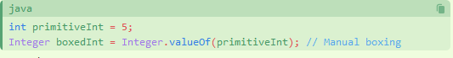

### Unboxing

Unboxing is the reverse process, where a wrapper class object is converted back to its corresponding primitive type.

Example:



### Auto-boxing

Auto-boxing is the automatic conversion that the Java compiler makes between the primitive types and their corresponding object wrapper classes. This feature was introduced in Java 5.

Example:

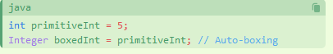

### Auto-unboxing

Auto-unboxing is the automatic conversion that the Java compiler makes from the wrapper class to the primitive type.

Example:

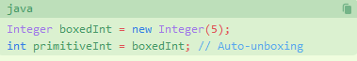

**>>**

In Java, you cannot override a variable, but you can hide it. Variable hiding occurs when a subclass declares a variable with the same name as a variable in its superclass. The variable in the superclass is hidden, not overridden, by the variable in the subclass

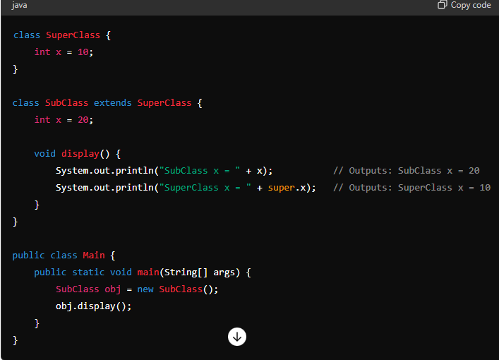

**>>**concrete class is the child class of abstract class which have all the implementation of abstract methods of abstract class

**>>** more on casting

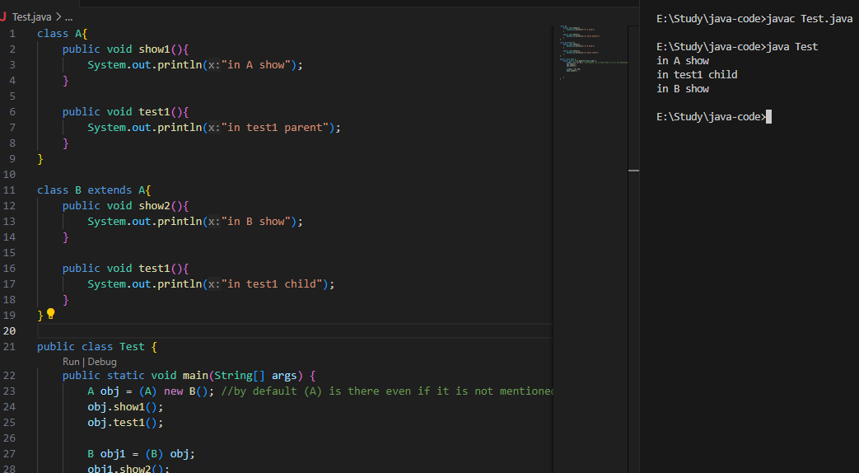

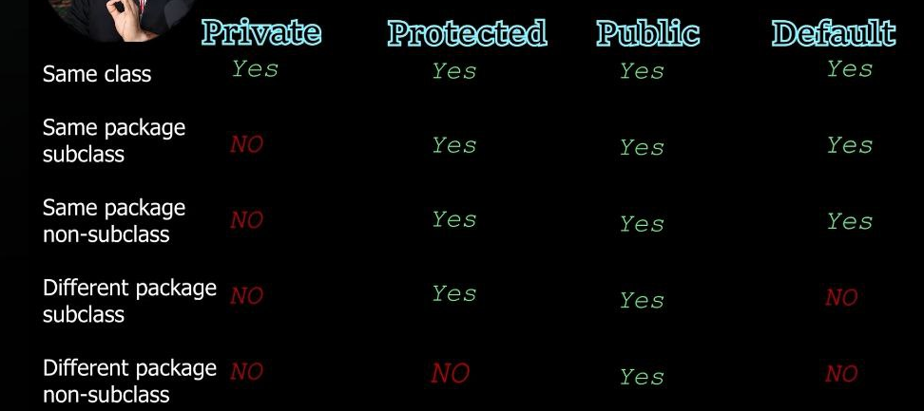

>>Inner Class

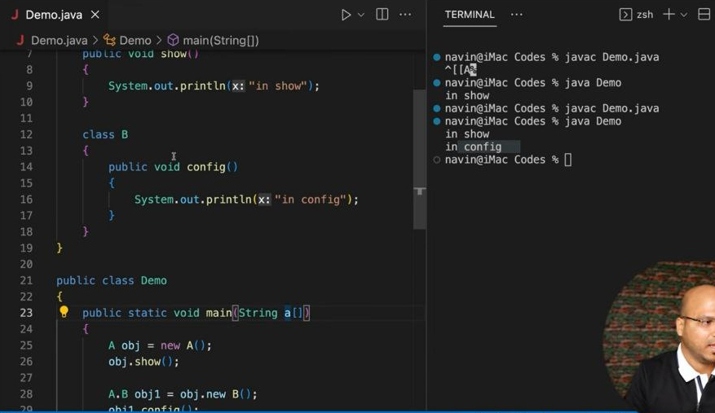

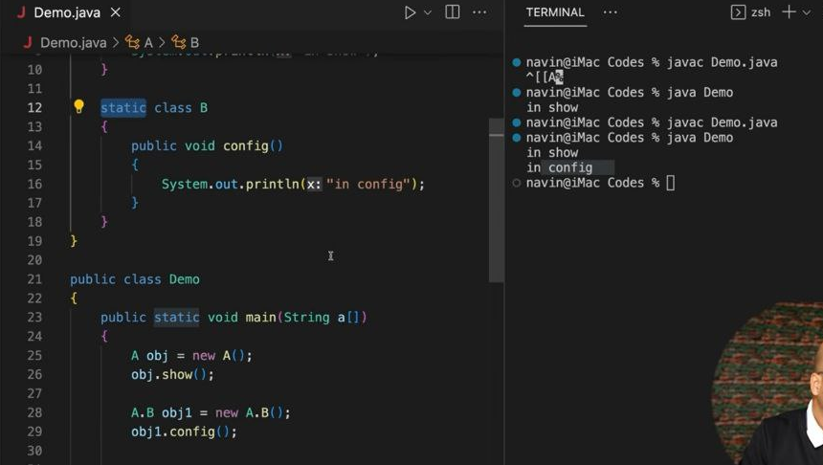

**>>Anonymous** object

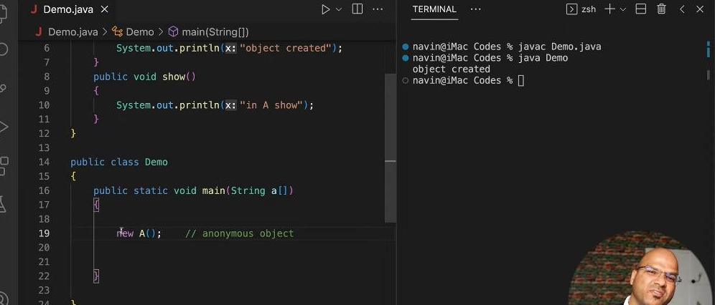

**>>**anonymous class/anonymous inner class

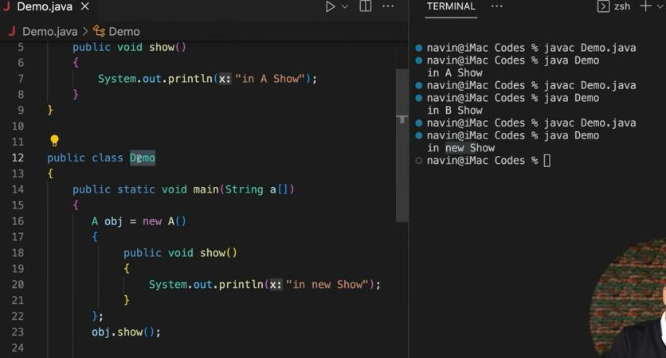

**>>**Anonymous inner class for an abstract class

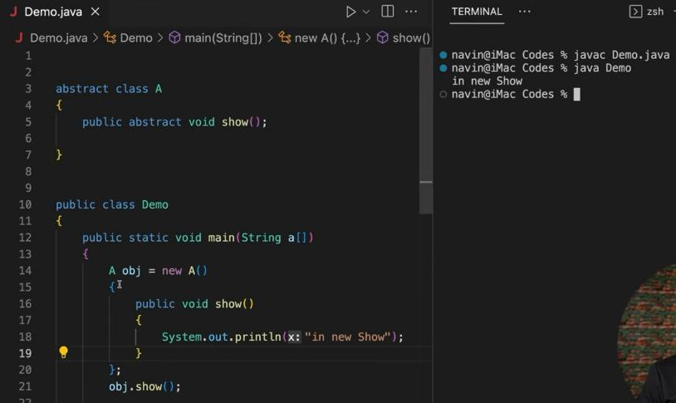

**>>**interface can have variables. those are by default static and final